# Heroku deployment

Steps for deployment an app in Heroku with Atlas Mongodb

## Create project on atlas.

Navegate to <https://cloud.mongodb.com/> login and create a new project

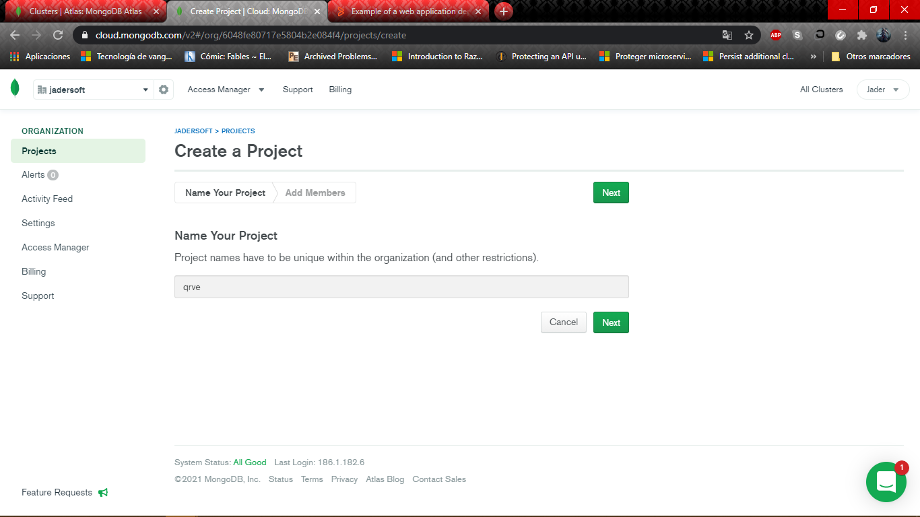

Next connect to its cluster and open the db for all ips

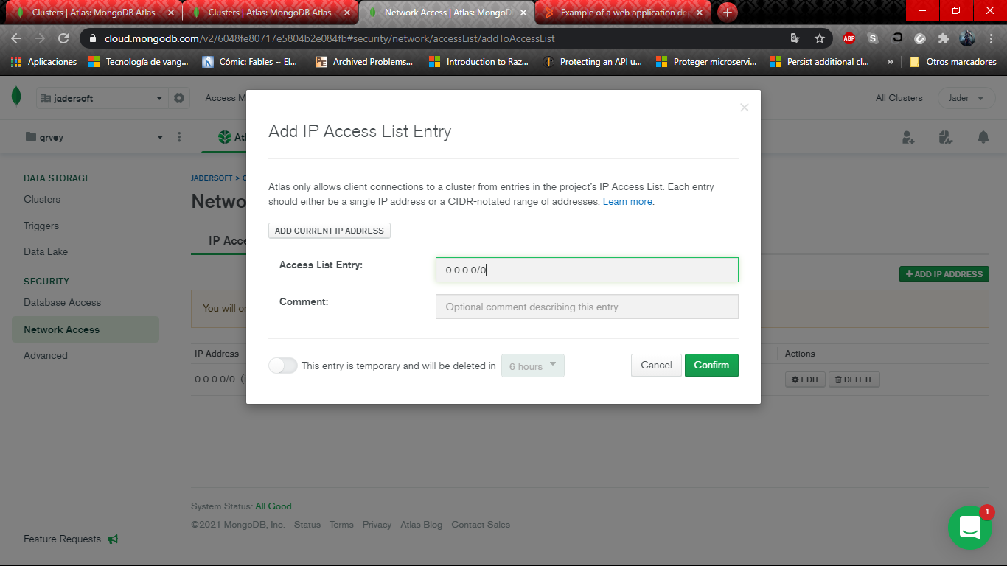

Select the type of connections

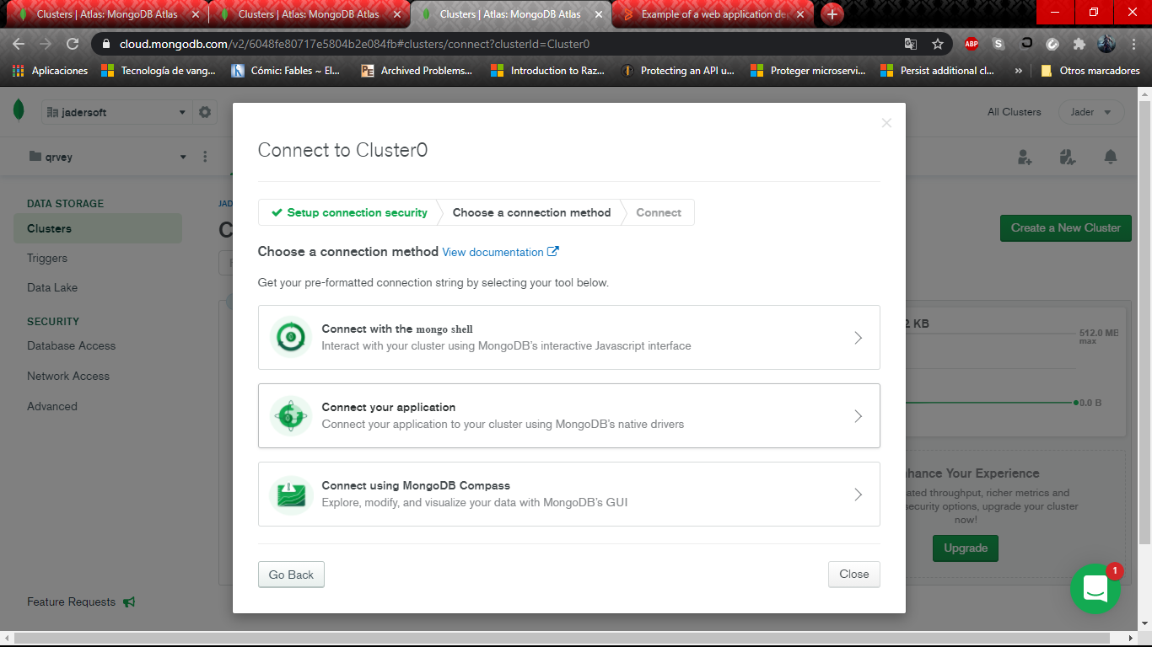

And get the connection string

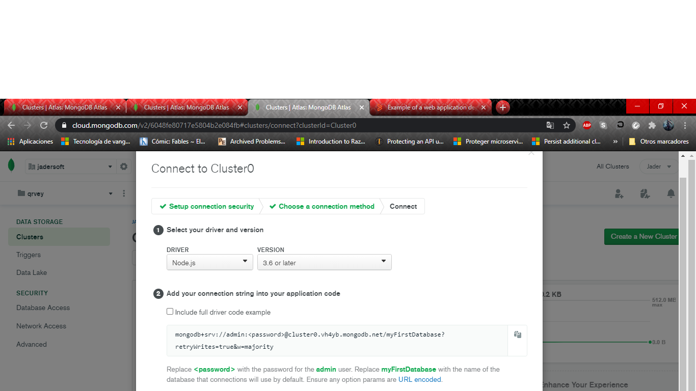

You’ll need to add your password for connect database properly

## Create app on Heroku

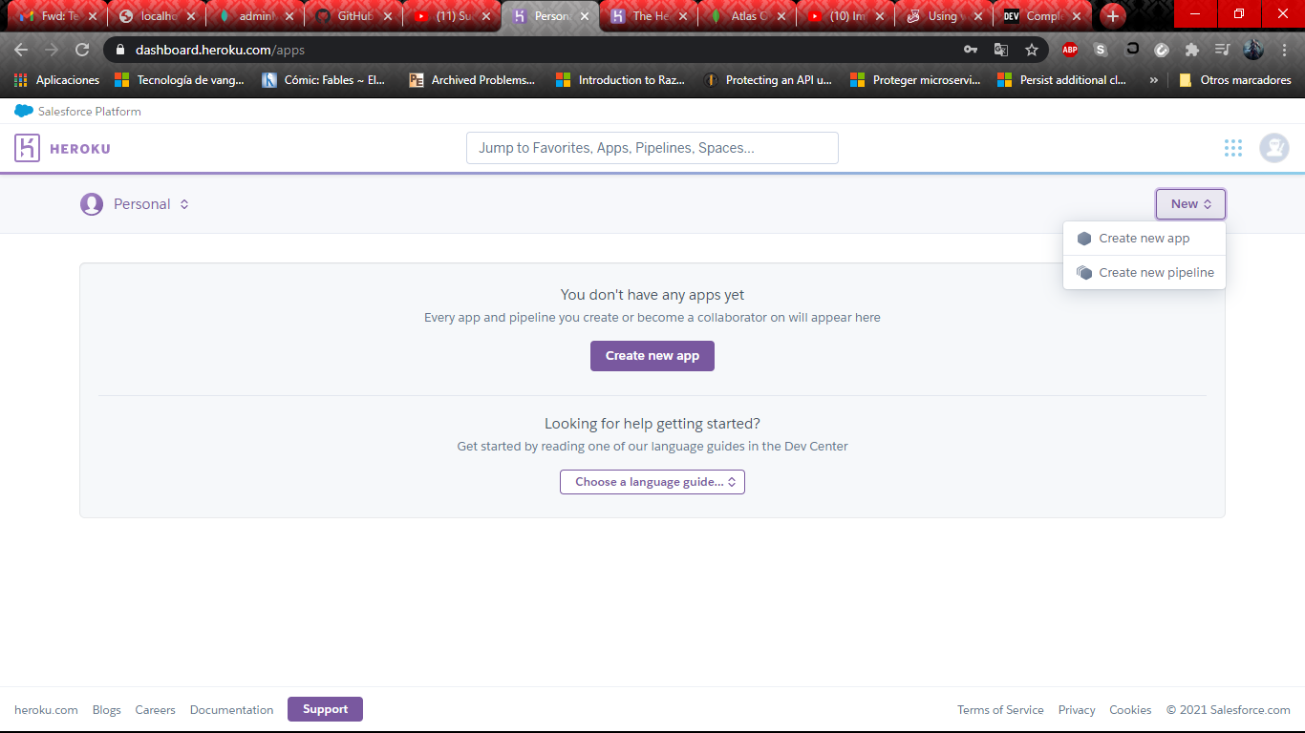

Create a new app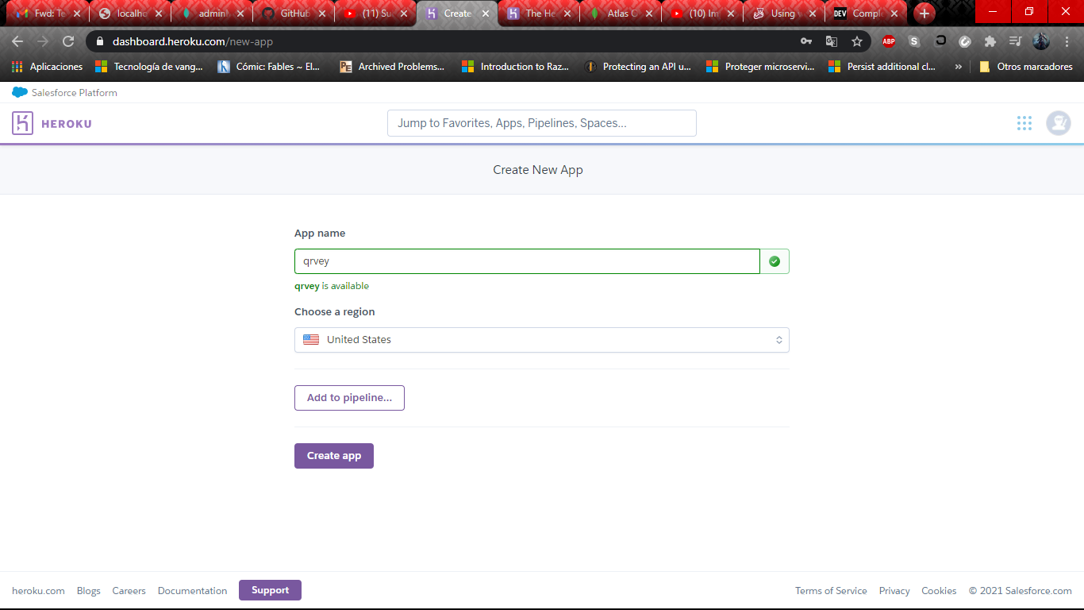

Select name and region

Then you’ll nedd to install Heroku Container CLI in your machine. You can get it on this link <https://devcenter.heroku.com/articles/heroku-command-line>

When you install Heroku container cli, you’ll need to login in console

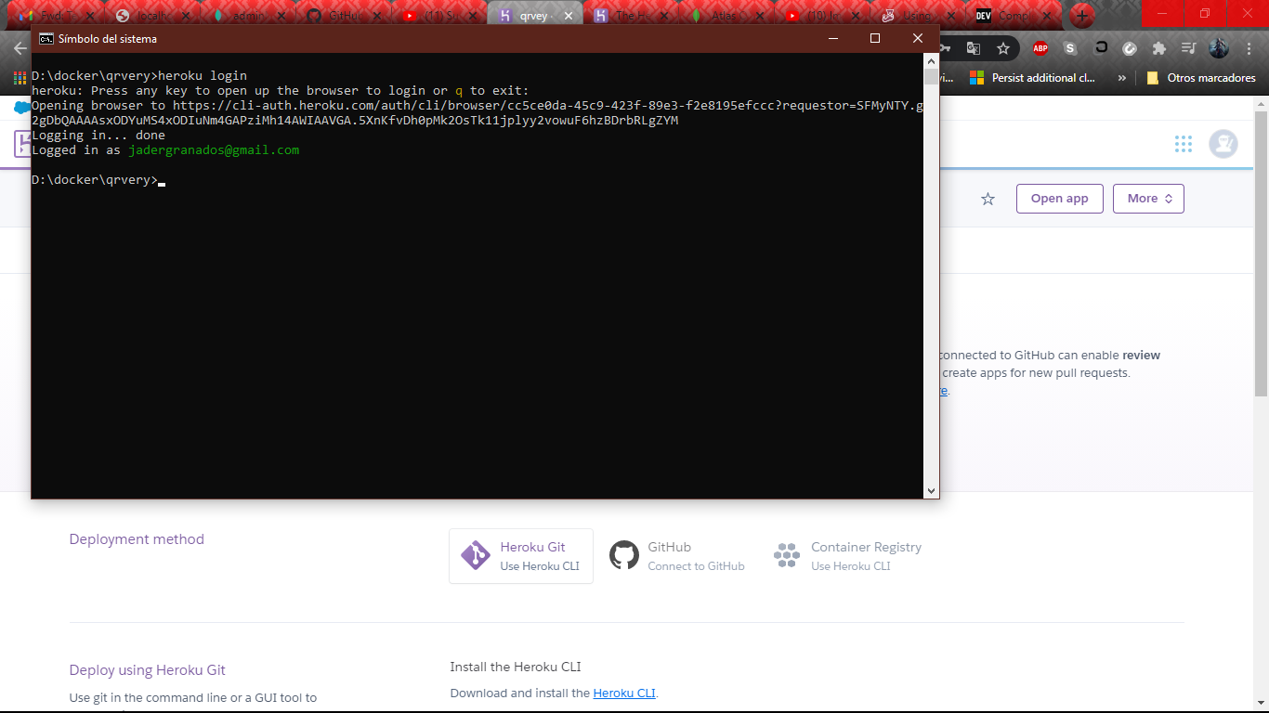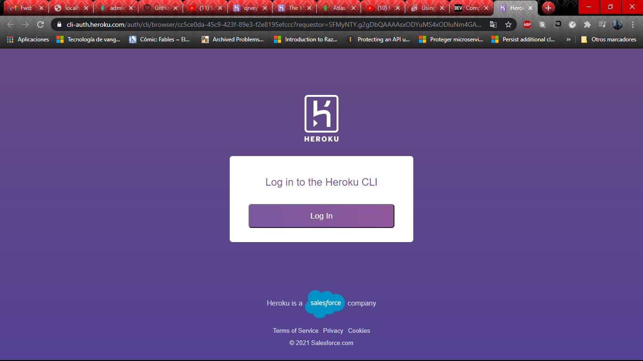

You can configure a file heroku.yml for making your life easier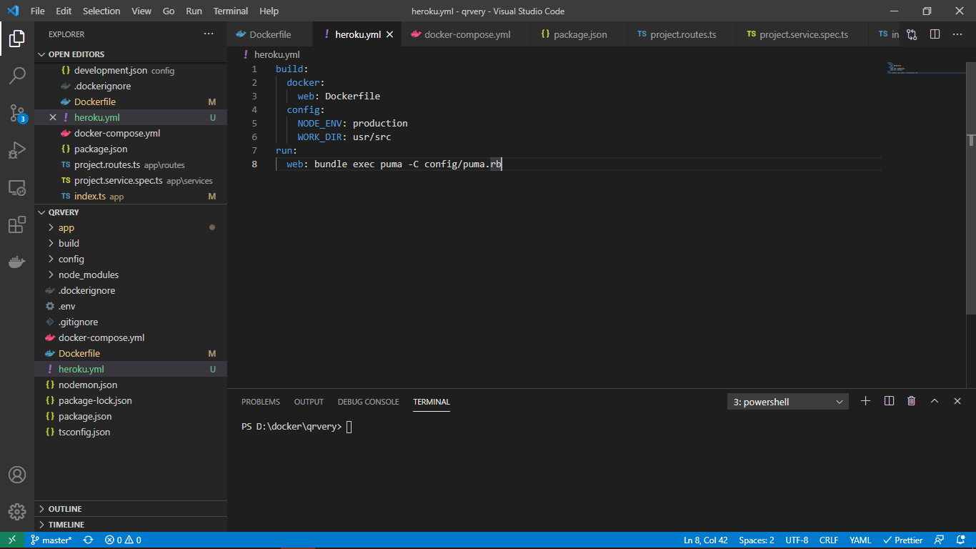

When all is ready for deploying, you write on console the next instructions:

heroku container:push web -a name_of_your_app

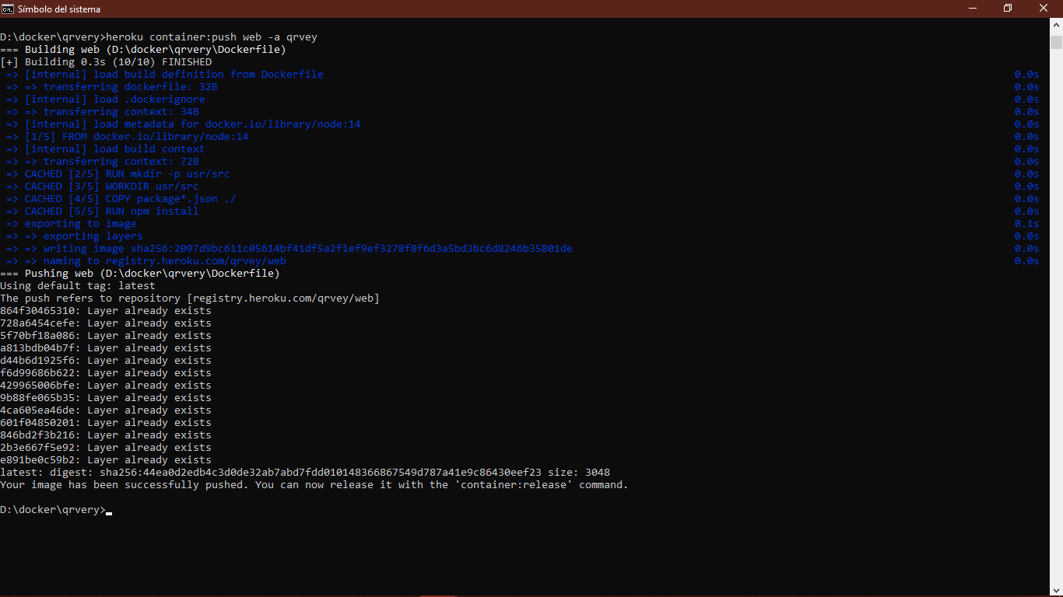

heroku container:release web -a name_of _your_app and heroku logs --tail for see what its happening on the server

